AI4001/CS4063 - Fundamentals of NLP/NLP Course Project.

Story2Audio Microservice

Members
21I-0560 Talha Arjumand
21I-2468 Albab Nawaz
21I-0730 Alian Anwar

Story2Audio Microservice
Overview
This project, Story2Audio, is developed as part of the AI4001/CS4063 - Fundamentals of NLP/NLP Course Project. It converts a given storyline into an engaging audio story using local models for text enhancement and text-to-speech (TTS). The project is implemented as a microservice with a gRPC API, a Gradio frontend for demo, and containerized deployment using Docker. The pipeline includes preprocessing, text enhancement, audio generation, and stitching, all wrapped in a scalable API with testing and documentation.
Project Phases
- Phase 1: Initial setup, environment configuration, and dependency installation.
- Phase 2: Core pipeline development (preprocessing, enhancement, TTS, audio stitching).
- Phase 3: gRPC API development with async support and error handling.
- Phase 4: Gradio frontend for user interaction with the API.
- Phase 5: Documentation, test cases, and performance evaluation.
Setup and Requirements
Prerequisites
- Operating System: Windows/Linux/MacOS
- Python: 3.11
- FFmpeg: Required for audio processing (pydub)
  - Windows: choco install ffmpeg
  - Linux/MacOS: sudo apt-get install ffmpeg or brew install ffmpeg
- Docker: For containerization
- Postman: For API testing
Dependencies
Install the required Python packages using the provided requirements.txt:
grpcio==1.71.0
grpcio-tools==1.71.0
transformers==4.51.3
torch==2.4.0
kokoro
pydub
soundfile
gradio
pytest
matplotlib
locust
Installation Steps
- Clone the repository:
- git clone <your-repo-url>
- cd <project-directory>
- Create and activate a virtual environment:
- python -m venv venv
- venv\Scripts\activate # Windows
- source venv/bin/activate # Linux/MacOS
- Install dependencies:
- pip install -r requirements.txt
- Ensure FFmpeg is installed (see Prerequisites).
Project Architecture
Pipeline Overview
The Story2Audio pipeline consists of the following stages:
- Text Preprocessing: Splits the input story into chunks (~150 words each) using src/preprocess.py.
- Text Enhancement: Enhances each chunk for emotional storytelling using tiiuae/falcon-rw-1b (src/enhancer_local.py).
- Text-to-Speech (TTS): Converts enhanced text to audio using hexgrad/Kokoro-82M (src/kokoro_tts.py).
- Audio Stitching: Combines audio chunks into a single .mp3 file using pydub (src/utils.py).
- gRPC API: Wraps the pipeline in a /GenerateAudio endpoint (api/server.py).
- Frontend: A Gradio interface for user interaction (frontend.py).

Architecture Diagram
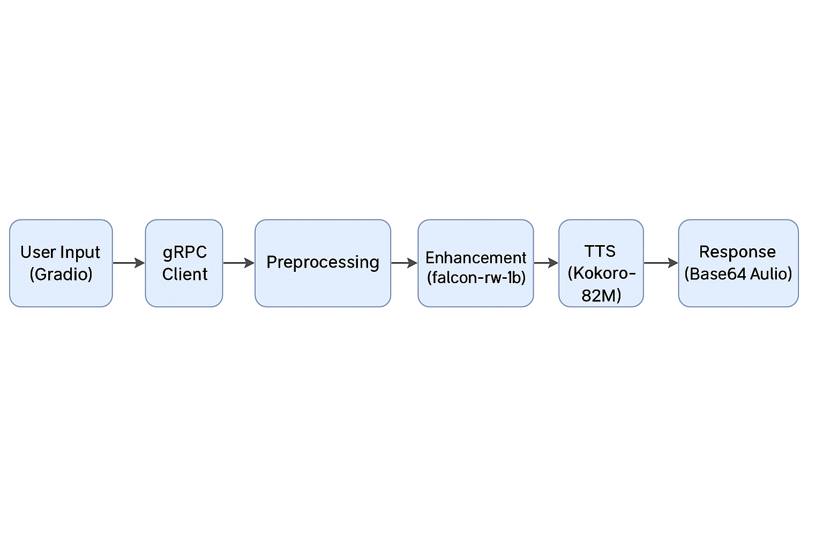
Directory Structure
Story2Audio/
├── api/
│ ├── client.py # gRPC client for testing
│ ├── grpc_client.py # gRPC client for frontend
│ ├── server.py # gRPC server implementation
├── src/
│ ├── enhancer_local.py # Text enhancement logic
│ ├── kokoro_tts.py # TTS logic
│ ├── preprocess.py # Story chunking logic
│ ├── utils.py # Audio stitching logic
├── tests/
│ ├── test_api.py # Unit tests for gRPC API
│ ├── performance_test.py # Performance test script
├── Dockerfile # Docker configuration
├── frontend.py # Gradio frontend
├── requirements.txt # Project dependencies
├── story2audio.proto # gRPC service definition
├── sample_story.txt # Sample input story
└── README.md # Project documentation
Models Used
- Text Enhancement: tiiuae/falcon-rw-1b (Hugging Face)
  - Used for enhancing storytelling tone.
  - Source: Hugging Face Model Hub
- Text-to-Speech: hexgrad/Kokoro-82M
  - Generates expressive audio from text.
  - Source: Local installation (assumed pre-downloaded as per Phase 2).

Usage
Running the gRPC Server
- Start the server:
- python api/server.py
- The server will run on localhost:50051.
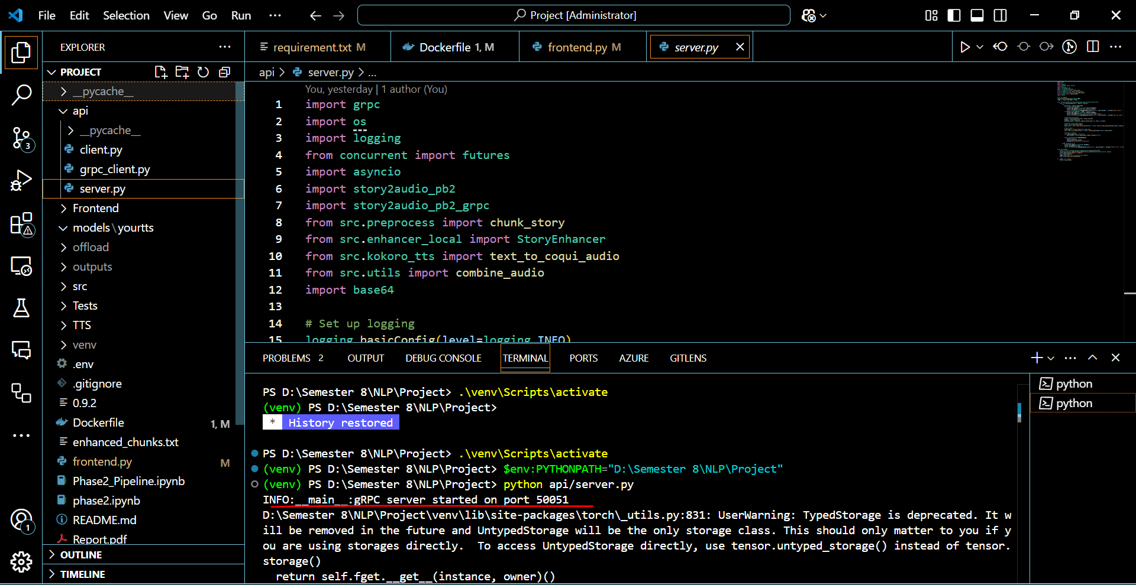
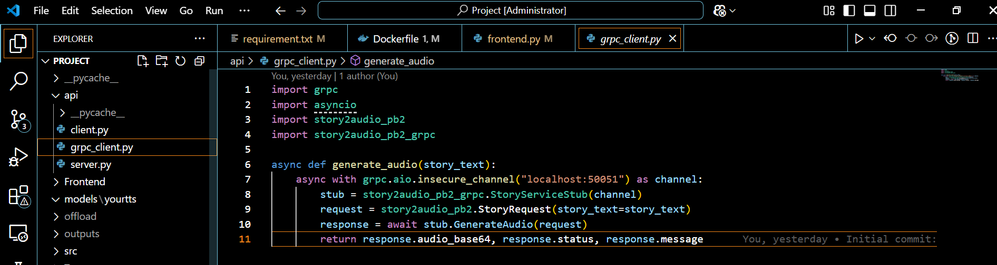
A reusable function to call the gRPC API from the frontend.
Using the Gradio Frontend
- Ensure the gRPC server is running.
- Launch the frontend:
- python frontend.py
- Open the provided URL (e.g., http://127.0.0.1:7860) in your browser.
- Enter a story in the text box and click "Generate Audio" to hear the output.
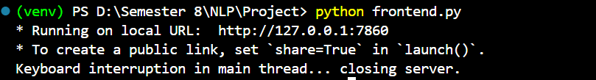
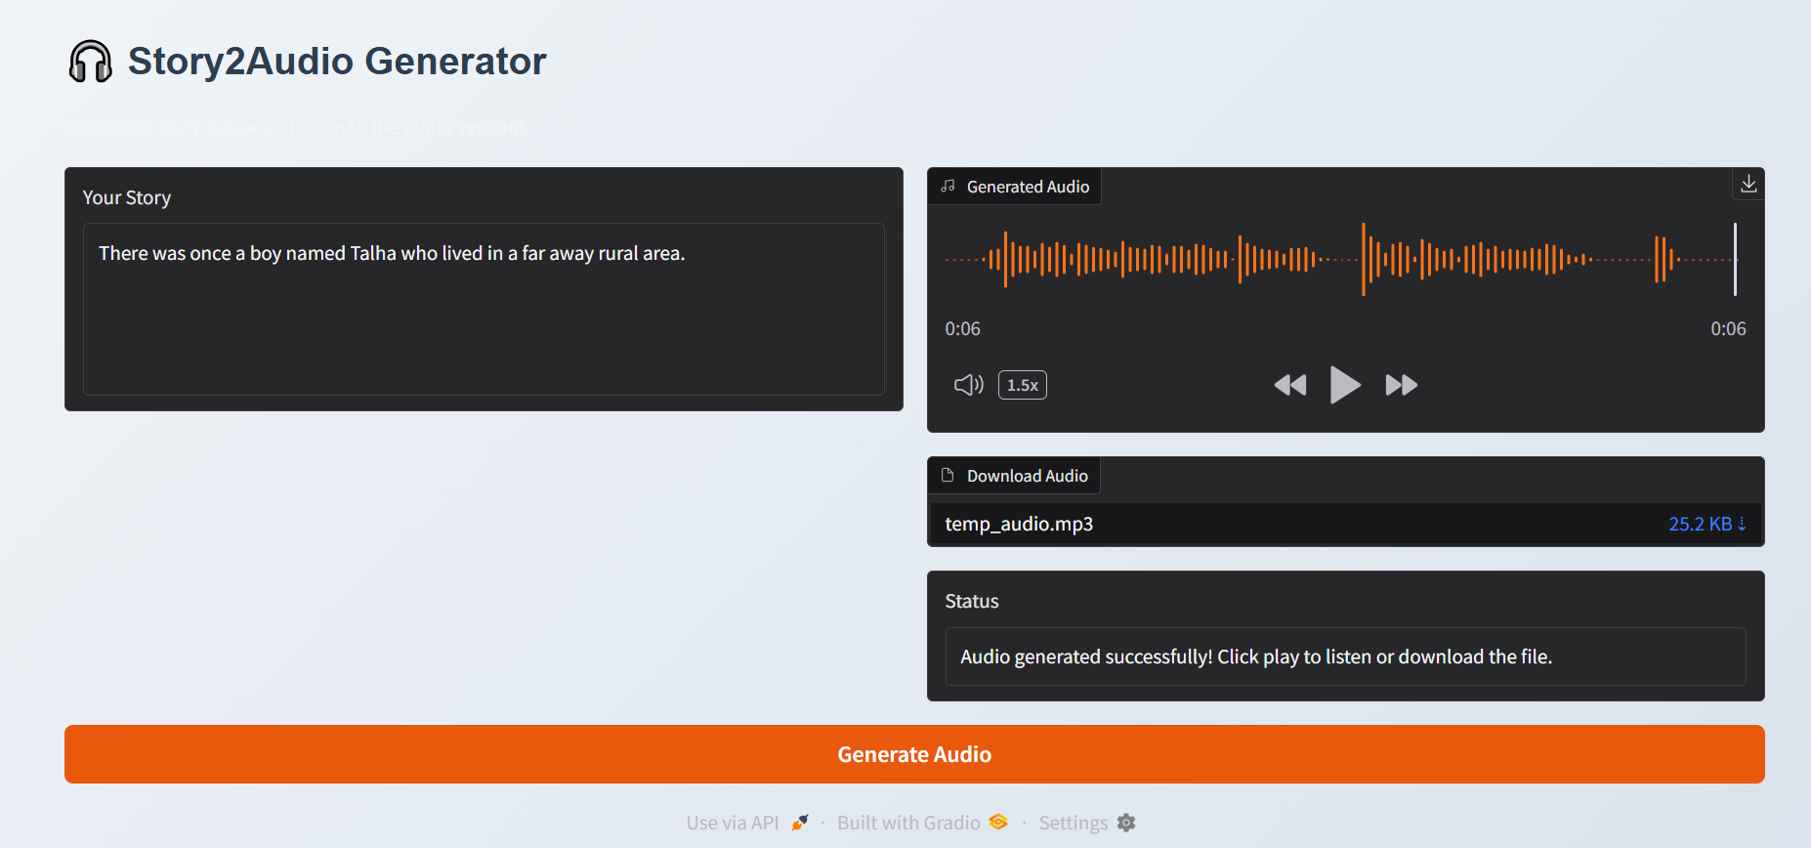

Testing with Postman
- Import story2audio.proto into Postman.
- Create a gRPC request to localhost:50051 with the GenerateAudio method.
- Send a request with a story (e.g., {"story_text": "Once upon a time..."}).
- Check the response for status, audio_base64, and message.
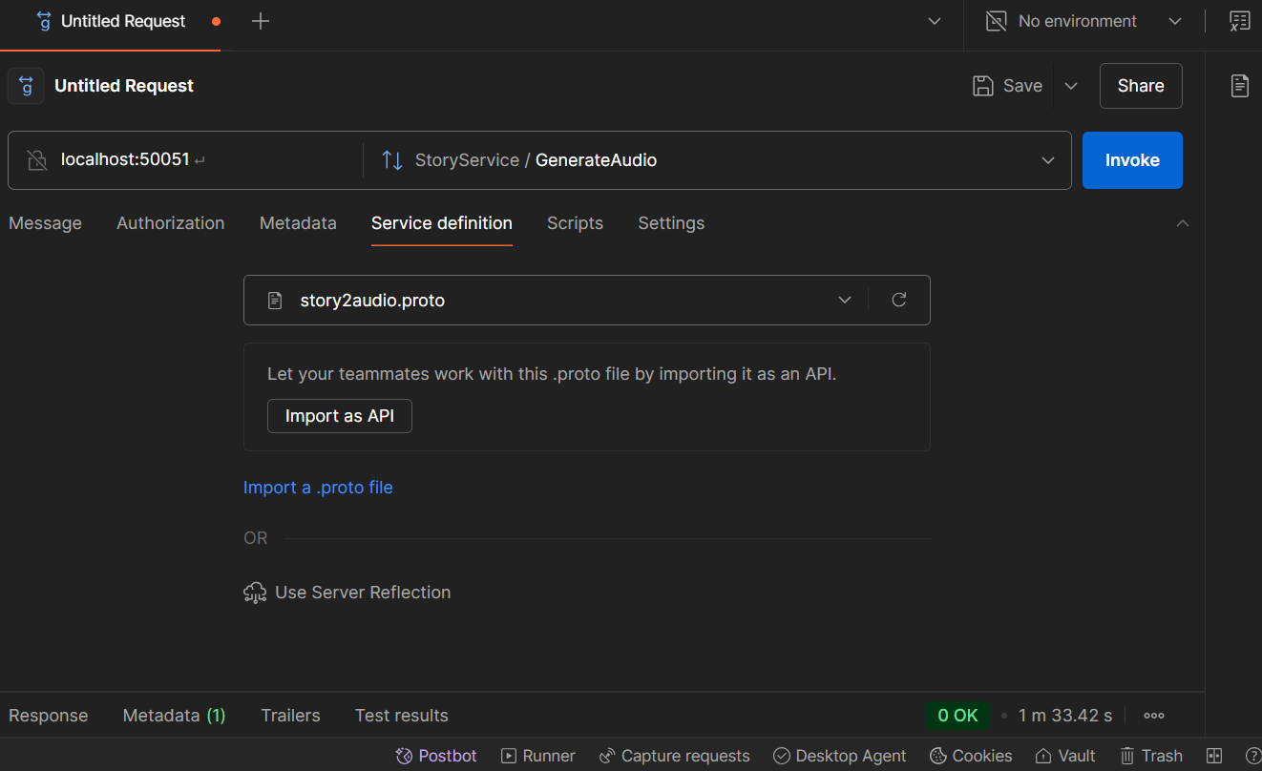
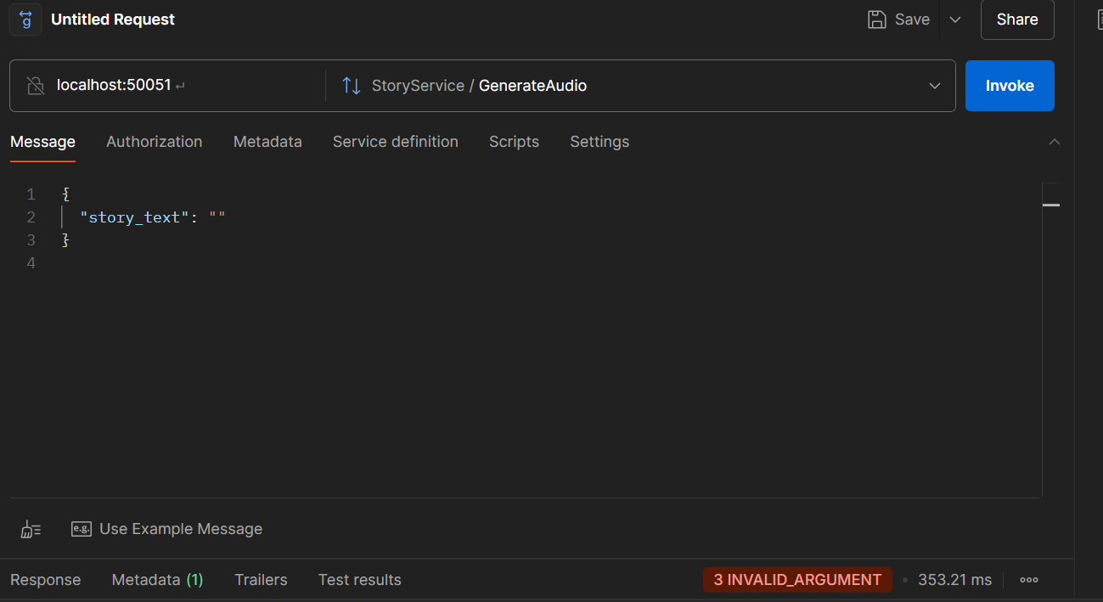

Test Cases and Results
Unit Tests
Unit tests for the gRPC API are implemented in tests/test_api.py. They cover:
- Successful audio generation
- Empty input handling
- Server error handling
Run Tests:
python -m pytest tests/test_api.py
Example Results:
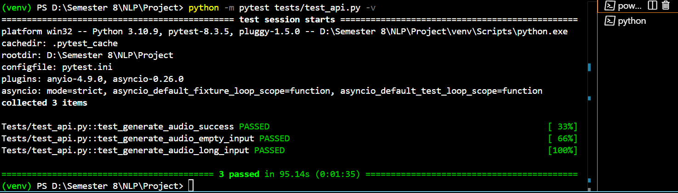

Performance Evaluation
Performance tests measure concurrent requests vs. response time using locust.
Run Performance Test:
- Start the gRPC server:
- python api/server.py
- Run the performance test:
- locust -f tests/performance_test.py --headless -u 10 -r 2 --run-time 1m
  - -u 10: 10 concurrent users
  - -r 2: Spawn rate of 2 users/sec
  - --run-time 1m: Run for 1 minute
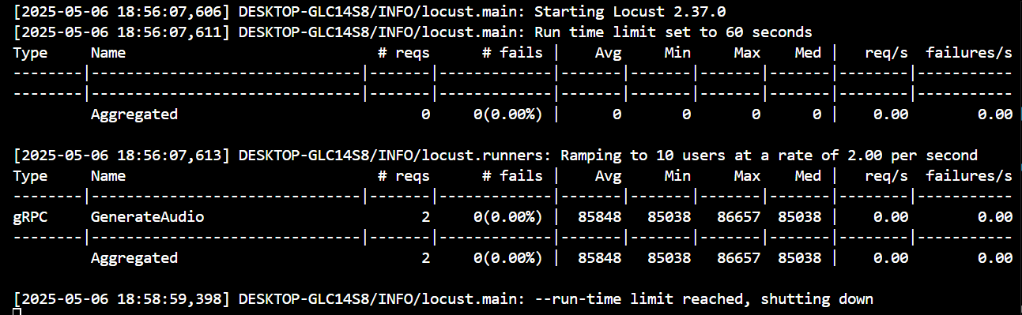
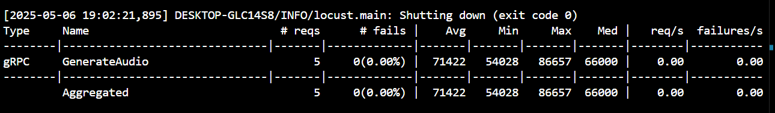

Results:
Performance Graph:
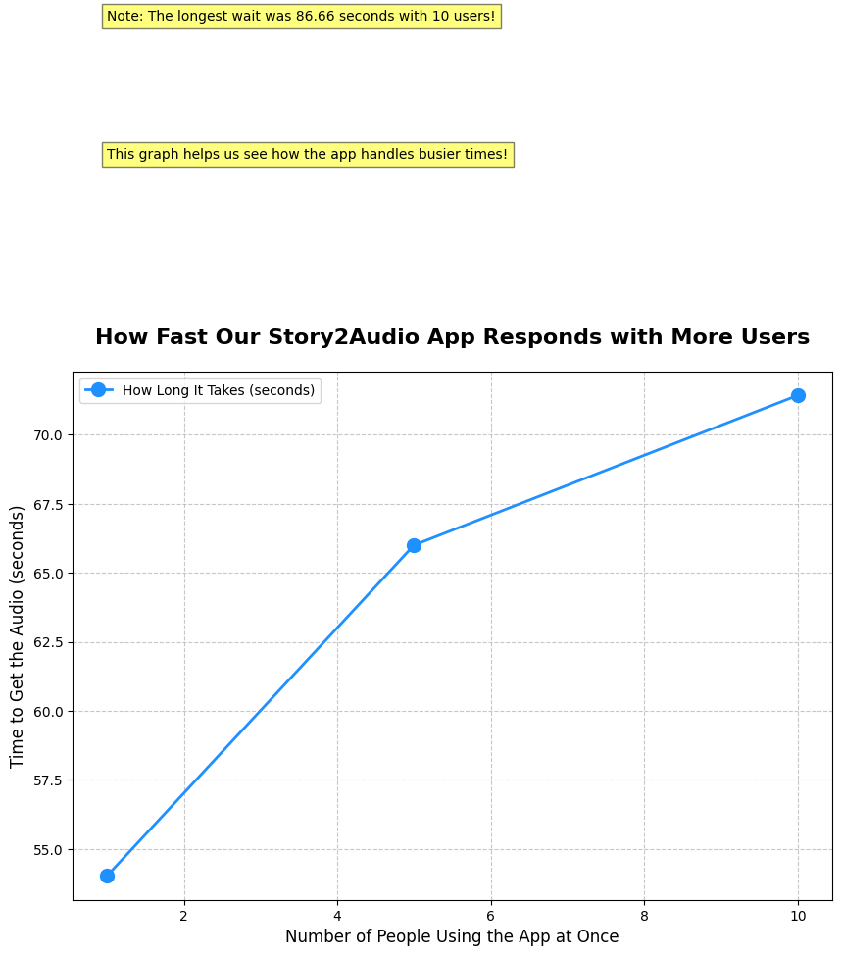

Limitations
- Model Constraints: falcon-rw-1b can be slow on CPU; GPU acceleration is recommended for production.
- Audio Quality: Kokoro-82M may struggle with certain accents or emotional tones.
- Scalability: The current setup may face bottlenecks with very high concurrency (>50 users) due to local TTS processing.
- Error Handling: Limited timeout handling for long audio generation tasks.
- Frontend: Gradio is suitable for demos but not production-grade.
Future Improvements
- Add GPU support for faster inference.
- Implement advanced timeout and retry mechanisms.
- Use a production-grade frontend framework (e.g., React).
- Optimize audio generation for higher concurrency.

Acknowledgments
- Models: tiiuae/falcon-rw-1b (Hugging Face), hexgrad/Kokoro-82M.
- Libraries: transformers, kokoro, pydub, gradio, grpcio.
Github Repo link:
https://github.com/Albab001/-Story2Audio-Microservice

